Brandon Wade

CPE301 – SPRING 2016

Design Assignment 4

**DO NOT REMOVE THIS PAGE DURING SUBMISSION:**

The student understands that all required components should be submitted in complete for grading of this assignment.

|  |  |  |  |
| --- | --- | --- | --- |
| **NO** | **SUBMISSION ITEM** | **COMPLETED (Y/N)** | **MARKS**  **(/MAX)** |
| 0. | COMPONENTS LIST AND CONNECTION BLOCK DIAGRAM w/ PINS |  |  |
| 1. | INITIAL CODE OF TASK 1/A |  |  |
| 2. | INCREMENTAL / DIFFERENTIAL CODE OF TASK 2/B |  |  |
| 3. | INCREMENTAL / DIFFERENTIAL CODE OF TASK 3/C |  |  |
| 4. | INCREMENTAL / DIFFERENTIAL CODE OF TASK 4/D |  |  |
| 5. | INCREMENTAL / DIFFERENTIAL CODE OF TASK 5/E |  |  |
| 6. | SCHEMATICS |  |  |
| 7. | SCREENSHOTS OF EACH TASK OUTPUT |  |  |
| 8. | SCREENSHOT OF EACH DEMO |  |  |
| 9. | VIDEO LINKS OF EACH DEMO |  |  |
| 10. | GOOGLECODE LINK OF THE DA |  |  |
|  |  |  |  |
|  |  |  |  |

|  |  |  |  |
| --- | --- | --- | --- |
| 0. | COMPONENTS LIST AND CONNECTION BLOCK DIAGRAM w/ PINS |  |  |

Atmel Studio 7.0

ATMega328P Chip

Breadboard

RGB LED

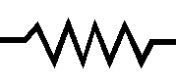3x Resistor

RGB LED

R

G

B

ATmega328P

PD6

PB1

PB3

|  |  |  |  |
| --- | --- | --- | --- |
| 1. | INITIAL CODE OF TASK 1/A |  |  |

/*

* DA4.c

*

* Created: 4/9/2016 8:31:48 PM

* Author : Brandon

*/

#define *F_CPU* 8000000UL //8 MHz

#include <avr/io.h>

#include <util/delay.h>

int main ()

{

unsigned int i, j, k; // used to update duty cycles

DDRD = 0xFF;

DDRB = 0xFF; // output mode

OCR0A = 25; // 10% duty start

TCCR0A = 1<<COM0A1|1<<COM0A0|1<<WGM00; // PWM mode, set/reset on OCRxA

TCCR0B = 0<<WGM02 |0<<CS02|0<<CS01|1<<CS00; // PWM mode with 1 pre scalar

OCR1A = 25; // 10% duty start

TCCR1A = 1<<COM1A1|1<<COM1A0|1<<WGM10|0<<WGM11; // PWM mode, set/reset on OCRxA

TCCR1B = 0<<WGM13 |0<<CS02|0<<CS01|1<<CS00; // PWM mode with 1 pre scalar

OCR2A = 25; // 10% duty start

TCCR2A = 1<<COM2A1|1<<COM2A0|1<<WGM20; // PWM mode, set/reset on OCRxA

TCCR2B = 0<<WGM22 |0<<CS02|0<<CS01|1<<CS00; // PWM mode with 1 pre scalar

while (1)

{

for(i = 25; i < 230; i+= 50)

{

OCR0A = i; // update OCRxA to approach 100% duty cycle

for(j = 25; j < 230; j+= 50)

{

OCR1A = j; // update OCRxA to approach 100% duty cycle

for(k = 25; k < 230; k+= 50)

{

OCR2A = k; // update OCRxA to approach 100% duty cycle

*_delay_ms*(500); // hold color

}

}

}

}

return 0;

}

|  |  |  |  |
| --- | --- | --- | --- |
| 6. | SCHEMATICS |  |  |

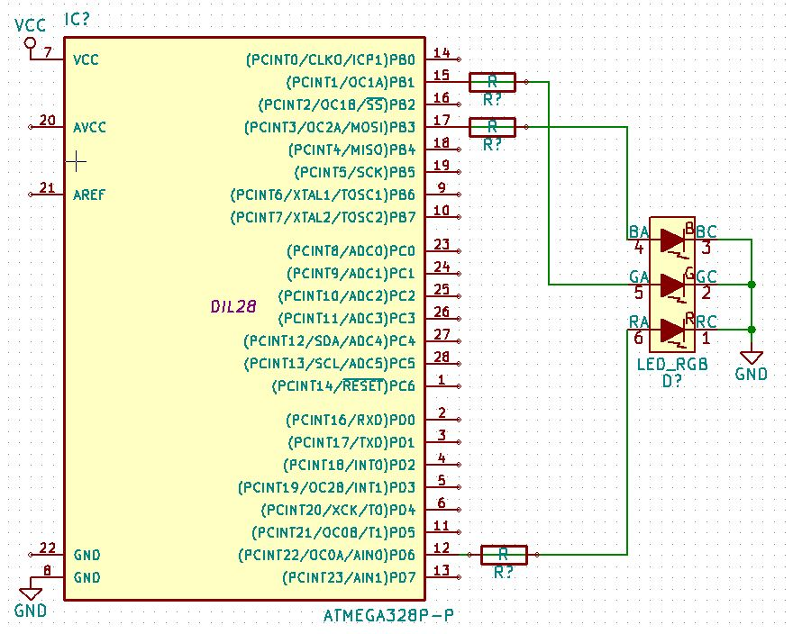

Each color of RGB LED connected to different PWM

|  |  |  |  |
| --- | --- | --- | --- |
| 7. | SCREENSHOTS OF EACH TASK OUTPUT |  |  |

TASK 1/A: Continuous Display of Temperature in F

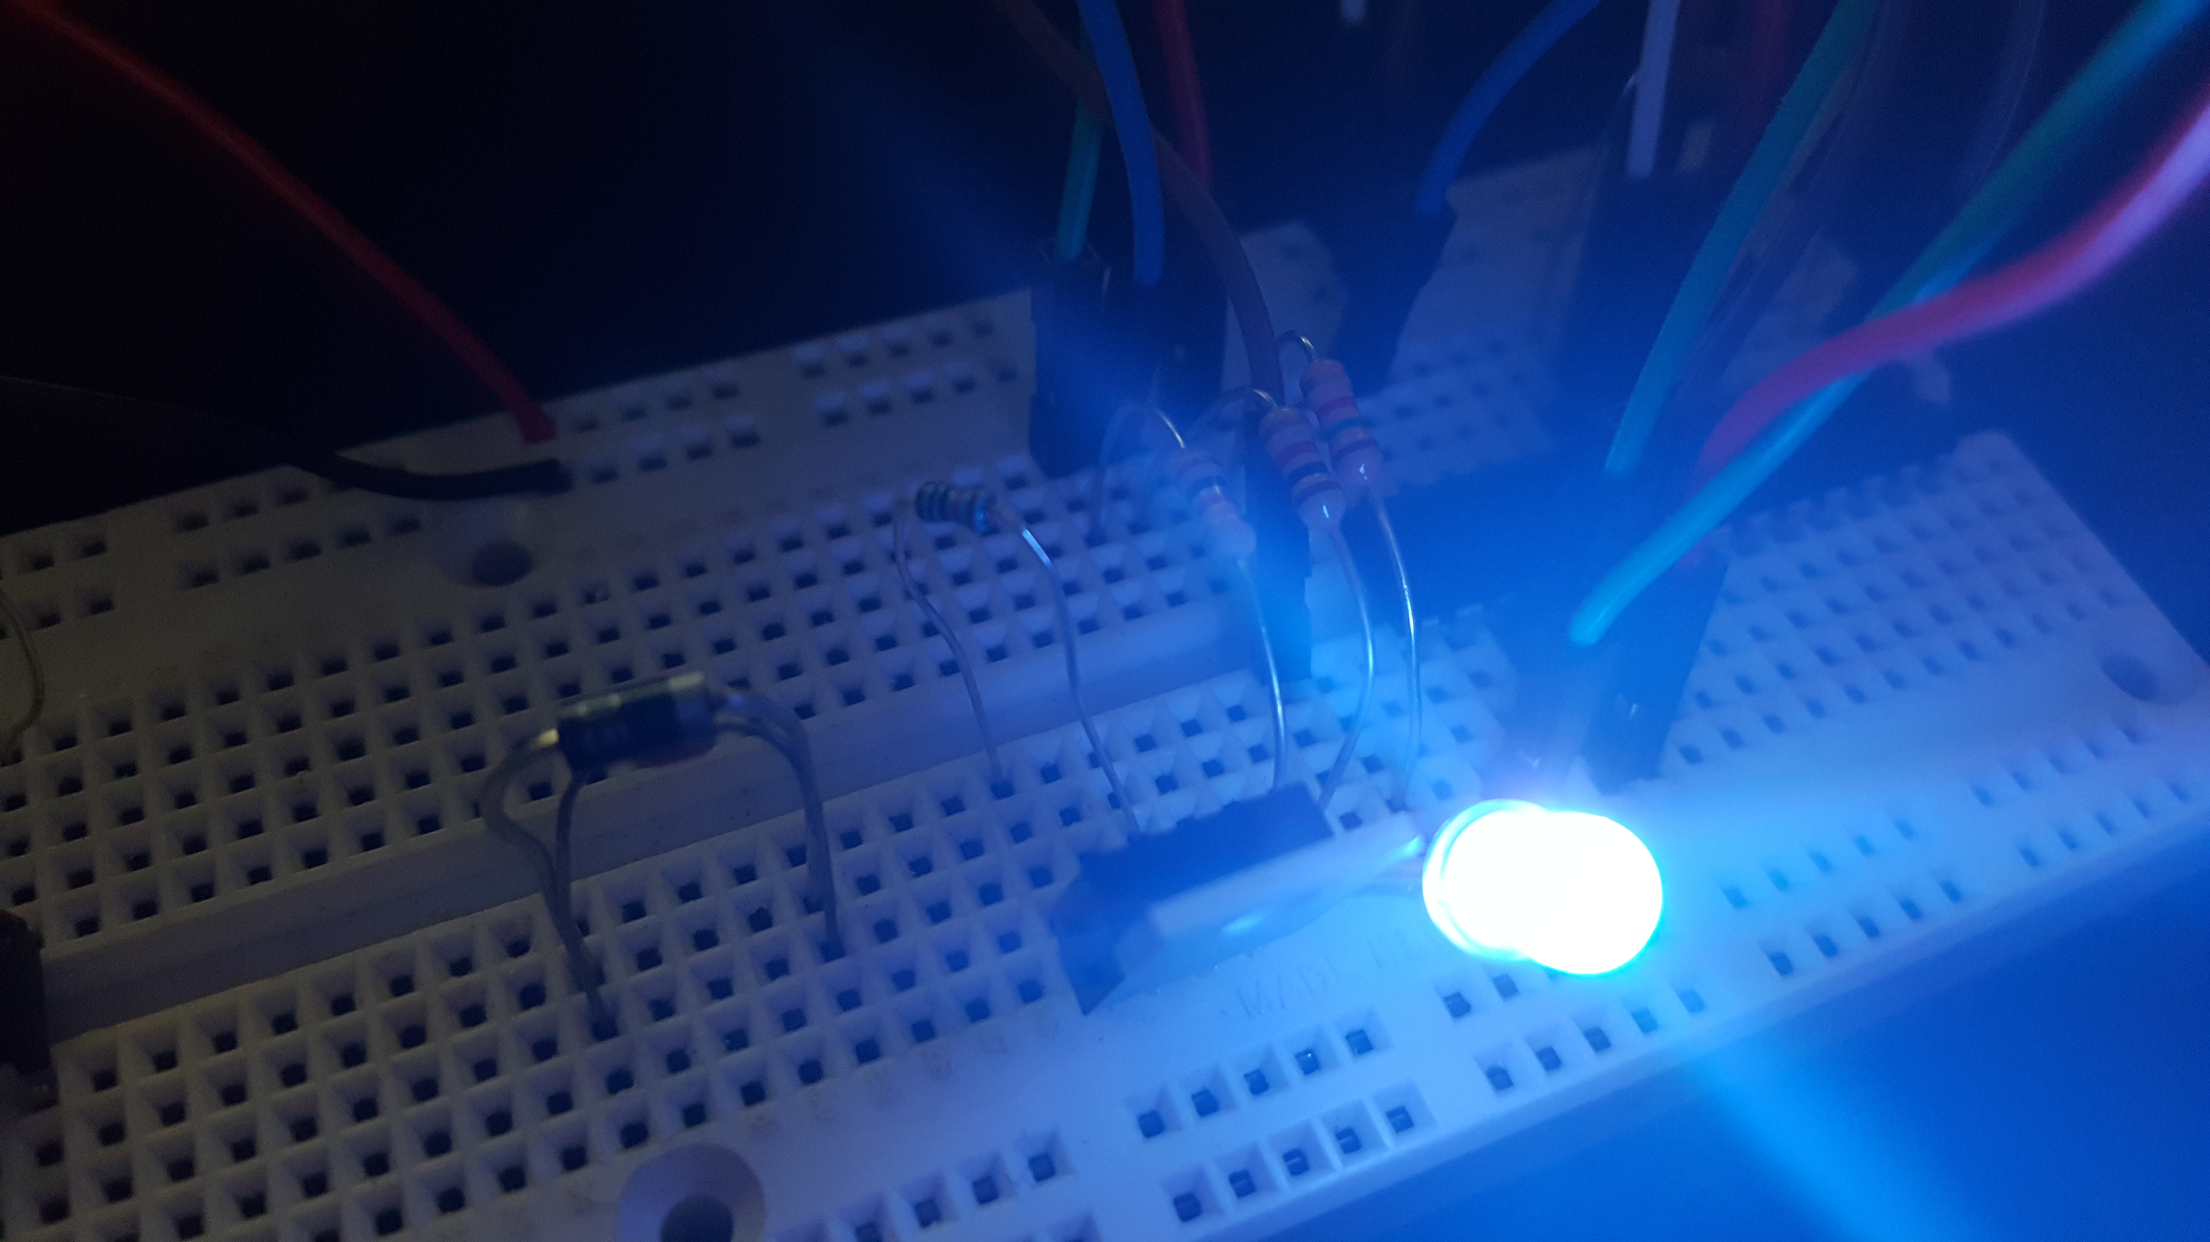

LED color starts at white, then decrements RED, once RED is at lowest brightness, GREEN gets decremented, once GREEN is at lowest brightness, BLUE is then decremented.

|  |  |  |  |
| --- | --- | --- | --- |
| 8. | SCREENSHOT OF EACH DEMO |  |  |

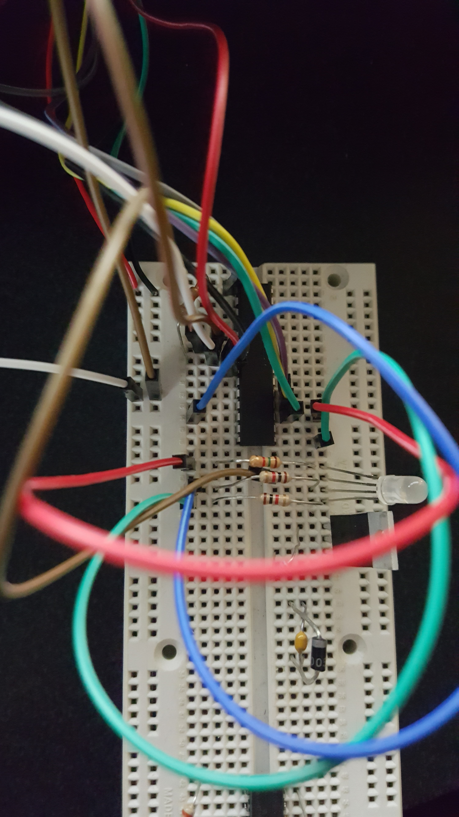

Red, green, and blue wires correspond to their respective colors. Each is connected to a OCRxA pin. 1500 Ohm resistors exist on Red and Blue lines of LED while a 1000 Ohm resistor exists on the Green line of the LED.

|  |  |  |  |
| --- | --- | --- | --- |
| 9. | VIDEO LINKS OF EACH DEMO |  |  |
| Task1 - <https://www.youtube.com/watch?v=e2huwJL2jHE> | | | |
| 10. | GOOGLECODE LINK OF THE DA |  |  |
| <https://github.com/wadeb1/KF3HF6ZFMP.git> | | | |

**Student Academic Misconduct Policy**

<http://studentconduct.unlv.edu/misconduct/policy.html>

“This assignment submission is my own, original work”.

Brandon Wade